## Brazil

Lead author(s): André Makishi (EPE), Roberto Brandão (GESEL)

Contributors: Bernardo Folly Aguiar (EPE), Diego Almeida (EPE), Jean Pereira (Furnas), José Bernardino (CBDB), Maria Regina Toledo (EPE), Rafael Kelman (PSR), Renato Haddad (EPE), Rodrigo Cusser (Furnas), Rodrigo Flora Calili (PUC), Ronaldo Souza (EPE), Roney Nakano (EPE), Thiago Ivanoski (EPE)

## Overview of the country’s/region’s electricity market

Brazil is the largest country in Latin America, with an electricity consumption of about 650 TWh (year 2019), as indicated in Figure 01, expecting to increase about 3% per year in next ten years.

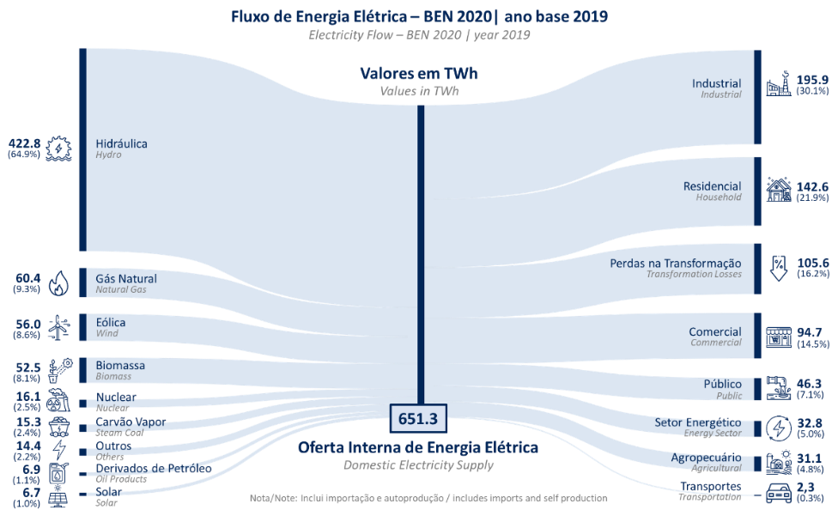

Figure 01 – Brazilian Energy Balance 2020 (year 2019)[1]

Installed capacity have reached more than 170GW in 2020, with a generation mix concentrated on renewable sources, with hydropower accounting for more than 60% of the country’s capacity. Existing hydro plants also provide a storage capacity of about 210TWh, supporting energy management across seasonal periods.

System interconnection has significantly expanded over last decades and currently have 147.528 km of transmission lines ranging from 132kV to 750kV, as indicated in Figure 02. Given its continental dimensions, transmission network have an important role for the system operation, considering regions with different climate and availability of resources.

Brazilian power sector is unbundled and activities are separated in generation, transmission and distribution (including retailing), with competition in the generation segment. The dispatch of power plants is performed by an Independent System Operator (ONS) using merit order determined by computational models.

There are two different energy trading environments: the “Free Market”, where free or special consumers and generators can negotiate bilateral contracts and the “Regulated Market”, where distribution companies buy energy from generation plants in public auctions coordinated by government, with long term contracts (usually between 20 and 30 years), being favourable to the investment and financing of new power plants such hydro and thermal. For both environments, government certifies the amount of tradable energy of each plant.

Agents transactions are accounted in short-term market by calculating the difference between produced or consumed and contracted energy. The imbalances are settled at an energy spot price, called PLD, which is calculated by computational models, taking into account the technical information of the system.

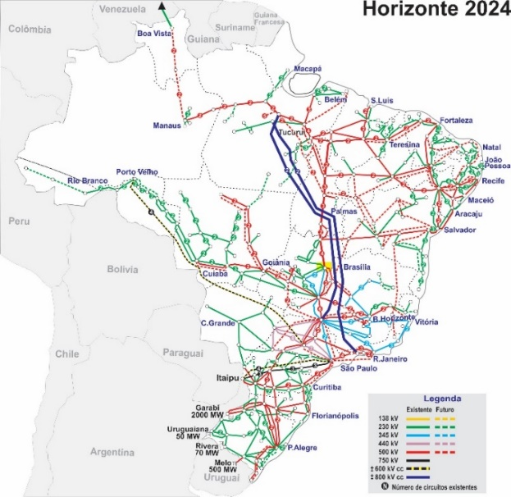Figure 02 – Existing and future transmission lines of Brazilian Interconnected System (Horizon 2024)[2]

Planning studies indicate an increasing participation of variable renewable generation in generation mix such wind and solar pv, as indicated in Figure 03, mainly due to reduced costs compared with others technologies in energy basis.

Additionally, as there are few conventional hydropower projects ready to be developed, especially hydro plants with regularization reservoir, the hydro storage capacity is not expected to grow, imposing future needs compatible with the attributes of PSH.

Several improvements in the electric sector regulatory framework are currently under discussion or are being implemented in a government initiative called “Power Sector Modernization”, including criteria for adequacy of supply, time resolution of energy prices in the wholesale market and ancillary services.

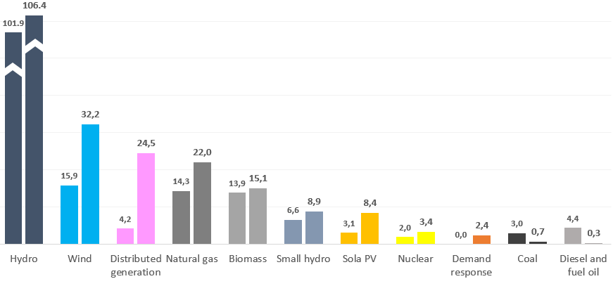

Figure 03 – Indicative evolution of installed capacity from 2020 to 2030[3]. Values indicated in GW.

## Current status of pumped storage & development potential

Four pumped storage plants were installed and commissioned in Brazil, between the end of the 1930s and mid of 1950s. However, from this total, one PSH was deactivated (Edgard de Souza), one operates as a pumping station only (Vigário) and the others do not operate like normal PSH due to the environmental and water management restrictions. These plants were constructed under a different market structure and regulatory framework. In the 1980s, state owned utilities (prior to unbundling) developed pump storage inventories, indicating a very large technical potential, but these sites were never explored. Many of them are no longer available due to socio environmental restrictions. In 2019, EPE started to develop a new evaluation of country potential for PSH, identifying sites with favourable conditions regarding technical, economic and environmental aspects, starting from Rio de Janeiro state[4], indicating a significant potential, but also a necessity to improve methodologies and procedures for a project definition and site selection. A tool for identification of sites with favourable conditions based on georeferenced information called GeoUHR was developed and was made publicly available[5]. Under a Research and Development (R&D) program of the regulation agency (ANEEL), different studies run by agents and institutions has been developed to evaluate the role of PSH in Brazilian interconnected system and to provide subsidies for market design, policies and regulation. In one of these studies, conducted by GESEL, simulations using high resolution modelling indicates that PSH are attractive compared with batteries and gas plants, considering economic aspects only. More information can be found at ([www.projetouhr.com.br](http://www.projetouhr.com.br/)). Other study under PSR leadership, proposes two approaches: bottom-up procedure investigates PSH alternatives through specific algorithms and optimization techniques considering engineering design and budgets and socioenvironmental impacts – an extension of the free-license HERA computational model, while a top-down perspective evaluates generic PHS candidate’s competitiveness in Brazilian system using optimization models.

## Challenges, barriers and emerging opportunities for pumped storage development

Current market structure and regulatory framework in Brazil do not consider commercialization of the different services that PSH can supply and they not provide a proper compensation of system wide benefits. As an example, ancillary services usually considered to compose PSH revenues, in Brazil are mandatory, and some services are compensated by a regulated revenue dedicated to cover only operational costs, which is not sufficient to incentive investments in new plants and technologies for this purpose. In addition, current procedures for environmental licensing, for concession, for water use authorization, for grid access and for operation, do not include PSH technology.

Predictable revenue streams is a key factor for financing new PSH projects, considering the high upfront costs and the corresponding long span of time needed to amortize the investments.

Despite of such challenges, recent improvements implemented or being discussed in Modernization program represent an opportunity and a first step for the insertion of PSH in Brazil. Energy price time resolution was recently updated, being calculated for each hour and for each submarket, improving the economic signal of energy price in the system and indicating the potential for energy arbitrage by storage technologies. Adequacy metric considered for system planning was also improved to capture current system needs, mainly related to instantaneous capacity, which also represents an opportunity for future insertion of PSH.

Although Brazil has a significant installed conventional hydropower base, energy demand is expected to grow further in the coming years. As result, power system must be expanded accordingly, considering all aspects related to cost and security of supply. Currently, large participation of hydropower in generation mix makes it possible to postpone the use of storage technologies like PSH. However, as indicated in page 2, the large penetration of renewable energy associated with reduction of new hydro projects indicates a relative decrease in the participation of conventional hydro in future power system, especially plants with regularization reservoir, representing a potential opportunity for PSH.

# Recommendations

As mentioned in page 2, several improvements in regulatory framework of Brazilian power sector are currently under discussion or are being implemented in a government initiative called “Power Sector Modernization” led by Ministry of Mines and Energy with participation of main sector institutions. In this sense, this paper proposes recommendations regarding PSH that could be considered inside this program.

1) Evaluate applicable mechanisms to improve predictability of revenue streams and risk allocation, to increase financial attractiveness and to compensate system wide benefits of PSH.

2) Evaluate and improve market rules to allow participation of storage technologies in electricity market, including regulatory impact analysis (RIA).

3) Adapt the regulatory framework to include and to allow development studies of PSH and procedures for site concession.

4) Adapt procedures for environmental permits and water use authorization for PSH. Develop studies and map potential impacts of PSH and codify the best practices for environmental impact evaluation.

5) Improve models and methodologies considered for evaluation of storage technologies for system planning purpose, regarding both generation and transmission expansion. Develop procedures for the valuation of wide spectrum benefits of PSH according to system features.

6) Adapt Grid Procedures to allow the insertion and operation of PSH in interconnected system. Evaluate models for operation and dispatch that maximize PSH benefits to the system, considering services associated with generation and transmission.

7) Continue PSH Inventory Studies, mapping favourable sites across the country, defining main technical characteristics, and ranking the best plants to be detailed in future studies. Establish procedures and criteria to develop studies and for site selection. Develop models to provide intensive alternative search and agility in decision making concerning technical and socioenvironmental aspects with previous stakeholder participation through an efficient visual interface.

8) Qualify professionals of the different stakeholders for specific features of PSH. Encourage working groups to exchange information and dissemination of studies related to PSH.

1. https://www.epe.gov.br/pt/publicacoes-dados-abertos/publicacoes/balanco-energetico-nacional-2020
2. http://www.ons.org.br/paginas/sobre-o-sin/mapas
3. https://www.epe.gov.br/pt/publicacoes-dados-abertos/publicacoes/plano-decenal-de-expansao-de-energia-2030
4. https://www.epe.gov.br/pt/publicacoes-dados-abertos/publicacoes/nt-006-2019-estudos-de-inventario-de-usinas-hidreletricas-reversiveis
5. https://www.epe.gov.br/pt/publicacoes-dados-abertos/publicacoes/ferramentas-geouhr-i-e-geouhr-ii